Proceed with the following link: <https://ks536.cichosting.com/ttp/tax/Search/search_tax.aspx>

**To Search by APN:**

1. Select Tax Type **“Real Estate (RL)** and Enter“**CAMA Number”** and Click on “**FIND NOW”**:

* APN Source: TAX ID, if N/A or No find use Order.APN.

If TAX ID format =NNN-NN-N-NN-NN-NNN.NN-N, (N-Numeric) it should be keyed without hyphens.

**EX:** 256-14-0-00-00-001.00-0 should be 256 14 0 00 00 001 00 0 (remove hyphens)

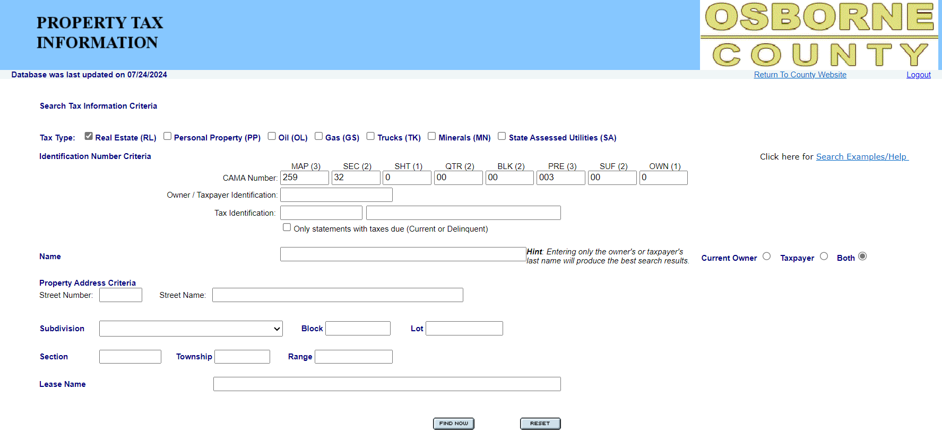

1. If APN search returned with either single or multiple results, then match **DTAPI TAX ID # with** **CAMA Number** like shown below. Select exact match and active account number to proceed.

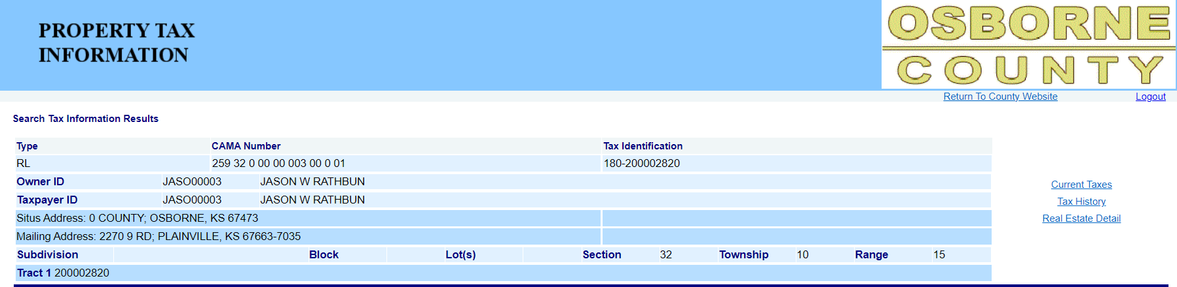

DTAPI input TAX ID # = **CAMA Number**

**For Property Address**

1. Enter **“Property Address Criteria”** and click on **“FIND NOW”:**
   1. **Source –** Tax Header.SitusAddress, if N/A or No- find user Order.Address)
   2. **Format –** Enter Street Number, Street Name on designated field
   3. Enter Street name without street direction (N, S, E, W) or suffixes (st,nd,rd,th,) or abbreviations for types of road (**Ave, Rd, St, Ln, Dr, Way, Pl, Blvd, Row, Plz, Ct, Sq, Byp, crossing, circle, etc.)**
   4. Ex: - For address **0 COUNTY** (exact format that is displayed on screenshot)

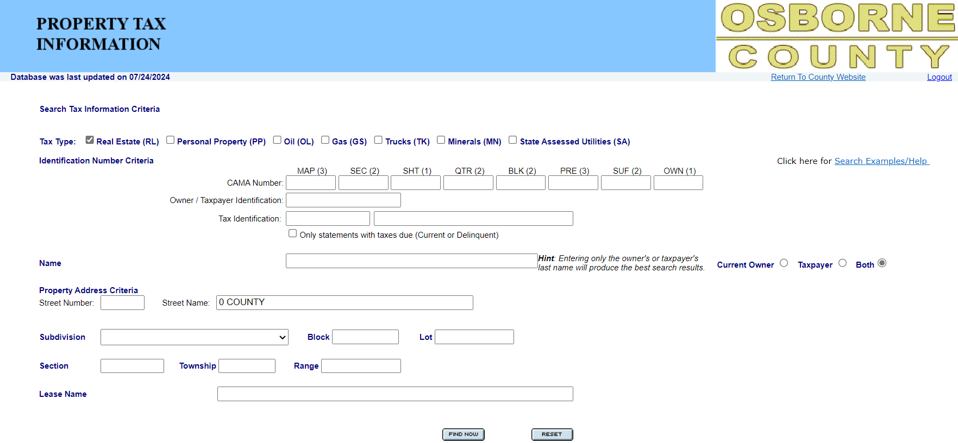

1. If property search returned with multiple results, then map **DTAPI TAX ID** with **CAMA Number,** from the results.



**Sample Current Year Taxes Paid:**

1. Screenshot and scrape the following results:



TaxHeader-APN/Tax_APN

TaxName/TaxName.Name1

1. After scraping the information, Click on “**Real Estate Details”:**



1. Screenshot and scrape the following:

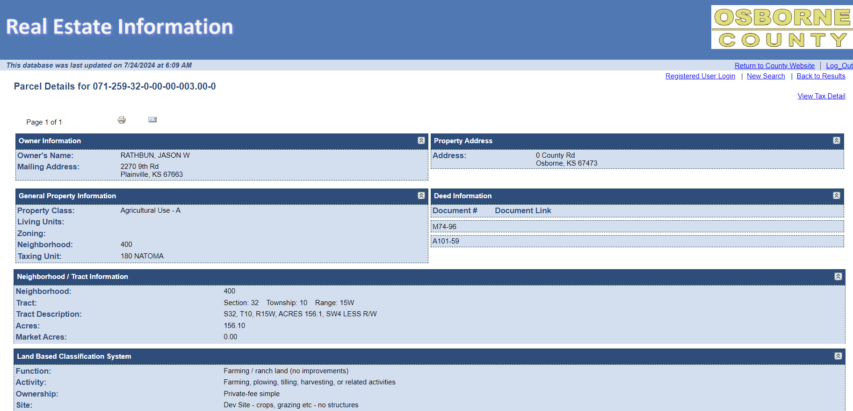

TaxHeader-TaxMailingAddress/TaxMailingAddress

Taxheader-TRA/TRACode

TaxDetails-Book.Page or TaxDetails-DocNumber

if instrument number is appearing like Book-Page then scrape like below format

Book should be before – (hyphen) and Page should be after – (hyphen)

If instrument don’t above rule then scrape instrument as TaxDetails-DocNumber

Taxheader-TRA/TRAName

TaxHeader-LegalDesc/BriefLegalDescription

Tax Header- Situs/SitusAddress

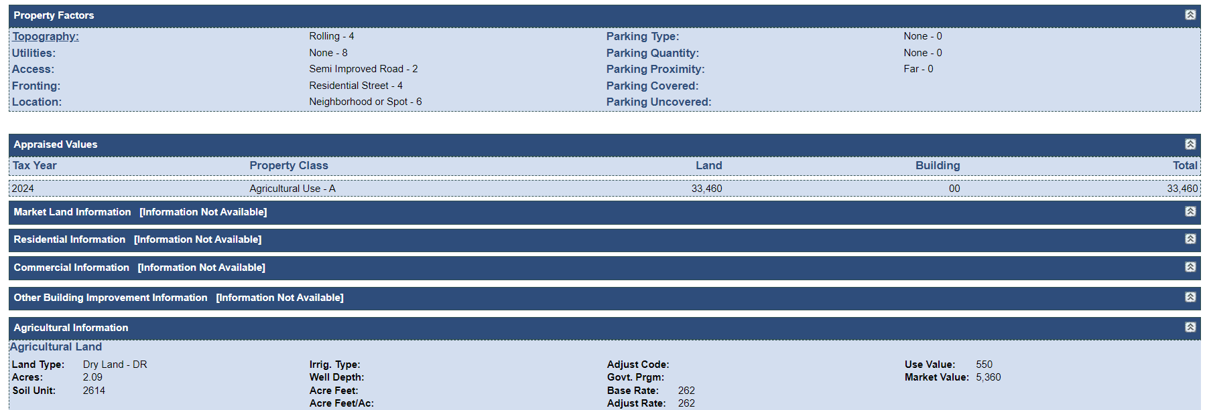

1. After Scraping **Real Estate Details,** Click on **“View Tax Details”:**

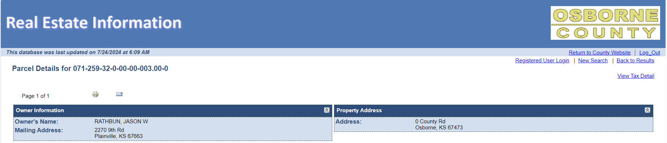

1. Click on **“Current Taxes”** under **Type “RL”:**



1. Screenshot and scrape the following result.

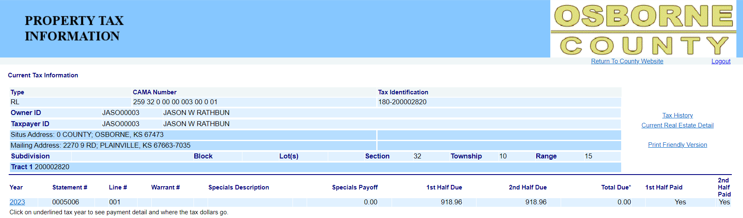

TaxDetail-SequenceNum/TaxType = “**Annual**”

ADD All 2nd half Due Amounts of current tax year then scrape as TaxDetail-TaxInstallment2/Installment2

ADD All 1st half Due Amounts of current tax year then scrape as TaxDetail-TaxInstallment1/Installment1

TaxHeader-Taxyear/TaxYear and

TaxDetail-TaxYear / TaxYear &

TaxDetail-ValueYear/ValueYear

If wording appears as “yes” then scrape Tax Detail-Status/Status1 = Paid. If wording appears as “No” then follow status rules

If wording appears as “yes” then scrape Tax Detail-Status/Status2 = Paid. If wording appears as “No” then follow status rules

1. Click on **“Year”:**



1. Screenshot and scrape the following result:

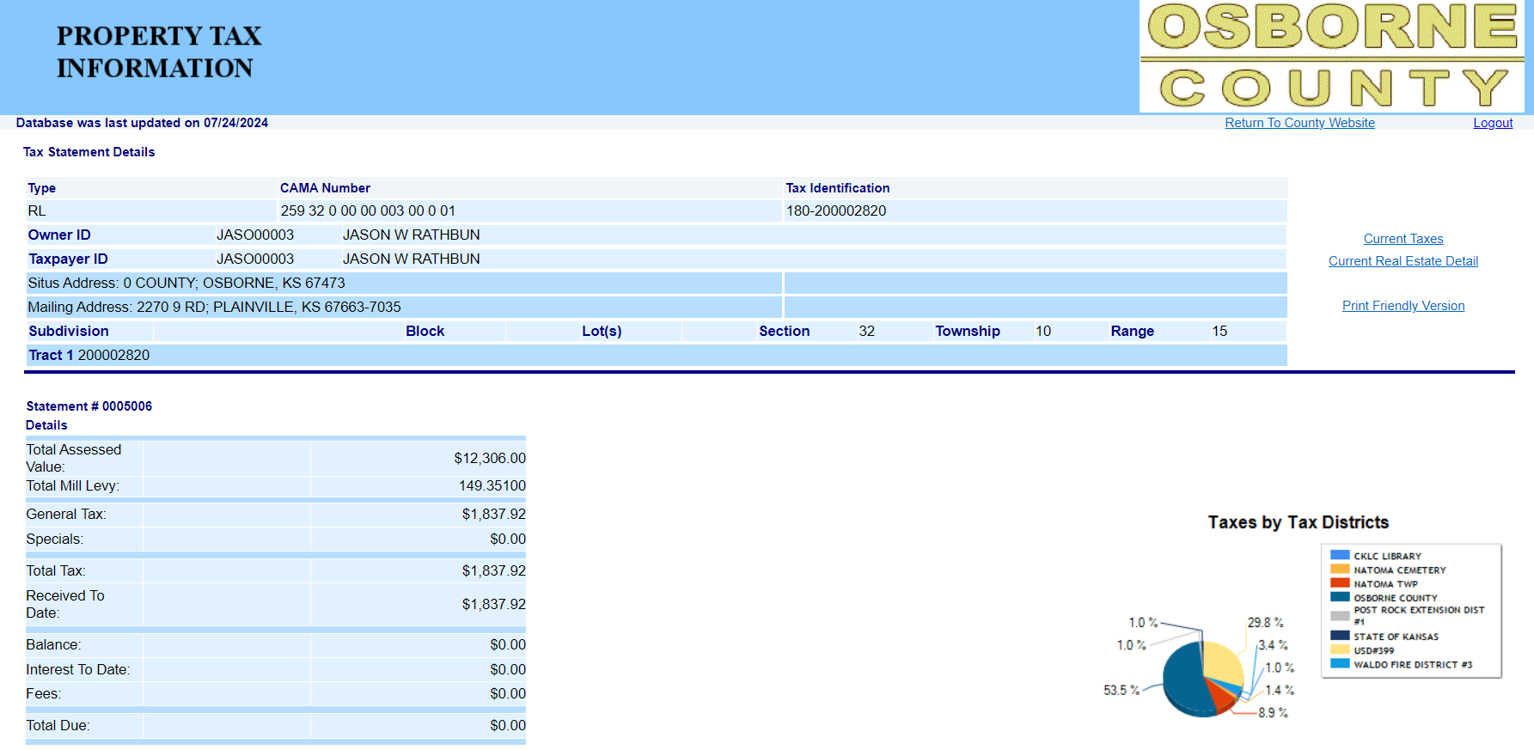

TaxDetail-NetVal /NetVal

If the Tax amount under receipt information is $0.00 and Total Due >$0.00 then Add Fees + Interest and scrape as TaxDetail-Interest1/Interest1

If the Tax amount under receipt information > $0.00 and Total Due is $0.00 then Add Fees + Interest and scrape as TaxDetail-Interest1/Interest1

if the Tax amount under receipt information > $0.00 and Total Due >$0.00 then Add Fees + Interest and scrape as TaxDetail-Interest2/Interest2

TaxDetail-Due1/AmountDue1 & TaxDetail-Due2/AmountDue2= $0.00 if Total due = $0.00

if Tax amount = $0.00 or none for current tax year under receipt information and total due >$0.00 then divide total due into two installments and scrape each amount as TaxDetail-Due1/AmountDue1 & TaxDetail-Due2/AmountDue2 respectively

if Tax amount > $0.00 for current tax year under receipt information and total due >$0.00 scrape total due as TaxDetail-Due2/AmountDue2 & TaxDetail-Due1/AmountDue1 = $0.00

TaxDetail-Due1/AmountDue1= 1st Installment-Tax amount under receipt information & TaxDetail-Due2/AmountDue2 = Total Due – (1st Installment-Tax amount under receipt information), when Tax amount under receipt information is less than 50% of Total Tax and Total Due is >$0.00

Taxheader-TaxRate/TaxRate

Add General Tax + Specials than scrape as

TaxDetail-TotalTax1/ TotalTax1

TaxDetail-TotalValue/TotalValue

When Total due under Details section is $0.00 then scrape this date to both fields TaxDetail-PaymentDate1/DatePaid1 &TaxDetail-PaymentDate2/DatePaid2

When Total due under Details section > $0.00 and tax amount > 0.00 then scrape this date as TaxDetail-PaymentDate1/DatePaid1

TaxDetail-PartialPayAmt1/PartialPayAmt1 &

TaxDetail-Partia2PayAmt2/PartialPayAmt2 = $0.00 if Tax = 0.00 or None

If Tax > $0.00 and Total due= $0.00 under details tab then divide Tax amount by two and scrape the amounts as PartialPayAmt1 and PartialPayAmt2 respectively

If Tax >$0.00 and Total due> $0.00 under details tab then scrape Tax amount as PartialPayAmt1 and PartialPayAmt2 =$0.00

**If Taxes Paid in 2 different dates:**

TaxDetail-Due1/AmountDue1 & TaxDetail-Due2/AmountDue2= $0.00 if Total due = $0.00

if Tax amount = $0.00 or none for current tax year under receipt information and total due >$0.00 then divide total due into two installments and scrape each amount as TaxDetail-Due1/AmountDue1 & TaxDetail-Due2/AmountDue2 respectively

if Tax amount > $0.00 for current tax year under receipt information and total due >$0.00 scrape total due as TaxDetail-Due2/AmountDue2 & TaxDetail-Due1/AmountDue1 = $0.00

TaxDetail-Due1/AmountDue1= 1st Installment-Tax amount under receipt information & TaxDetail-Due2/AmountDue2 = Total Due – (1st Installment-Tax amount under receipt information), when Tax amount under receipt information is less than 50% of Total Tax and Total Due is >$0.00

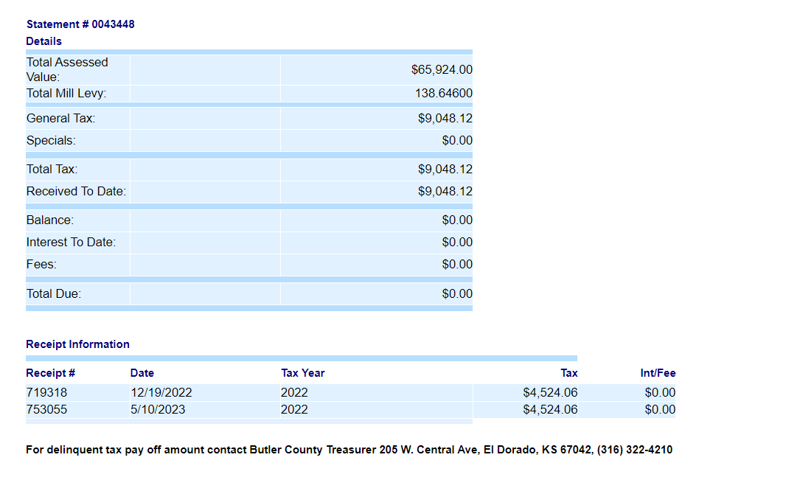

If the Tax amount under receipt information is $0.00 and Total Due >$0.00 then Add Fees + Interest and scrape as TaxDetail-Interest1/Interest1

If the Tax amount under receipt information > $0.00 and Total Due is $0.00 then Add Fees + Interest and scrape as TaxDetail-Interest1/Interest1

if the Tax amount under receipt information > $0.00 and Total Due >$0.00 then Add Fees + Interest and scrape as TaxDetail-Interest2/Interest2

Add General Tax + Specials than scrape as

TaxDetail-TotalTax1/ TotalTax1

Latest date should be considered TaxDetail-PaymentDate2/DatePaid2

Older date should be considered as TaxDetail-PaymentDate1/DatePaid1

TaxDetail-PartialPayAmt1/PartialPayAmt1

TaxDetail-Partia2PayAmt2/PartialPayAmt2

**Sample Current Year Taxes Due:**

1. Select Tax Type **“Real Estate (RL)** and Enter **“CAMA Number”** and click on **“FIND NOW”:**

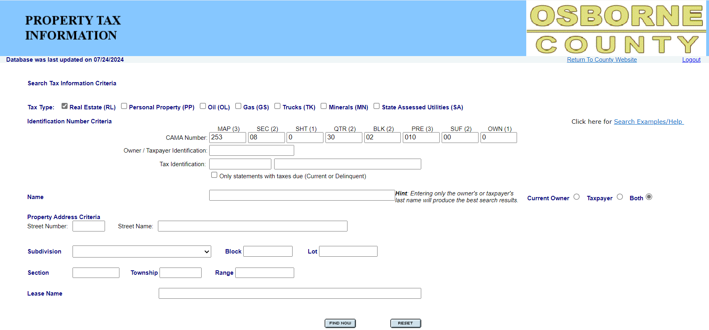

1. Click on “**Real Estate Details”:**

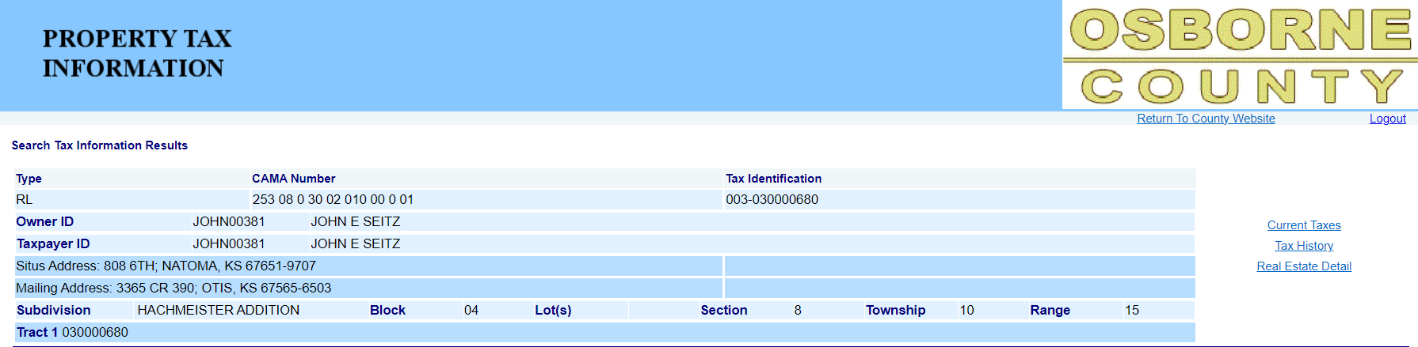

1. Screenshot and scrape the following:

TaxDetails-Book.Page or TaxDetails-DocNumber

if instrument number is appearing like Book-Page then scrape like below format

Book should be before – (hyphen) and Page should be after – (hyphen)

If instrument don’t above rule then scrape instrument as TaxDetails-DocNumber

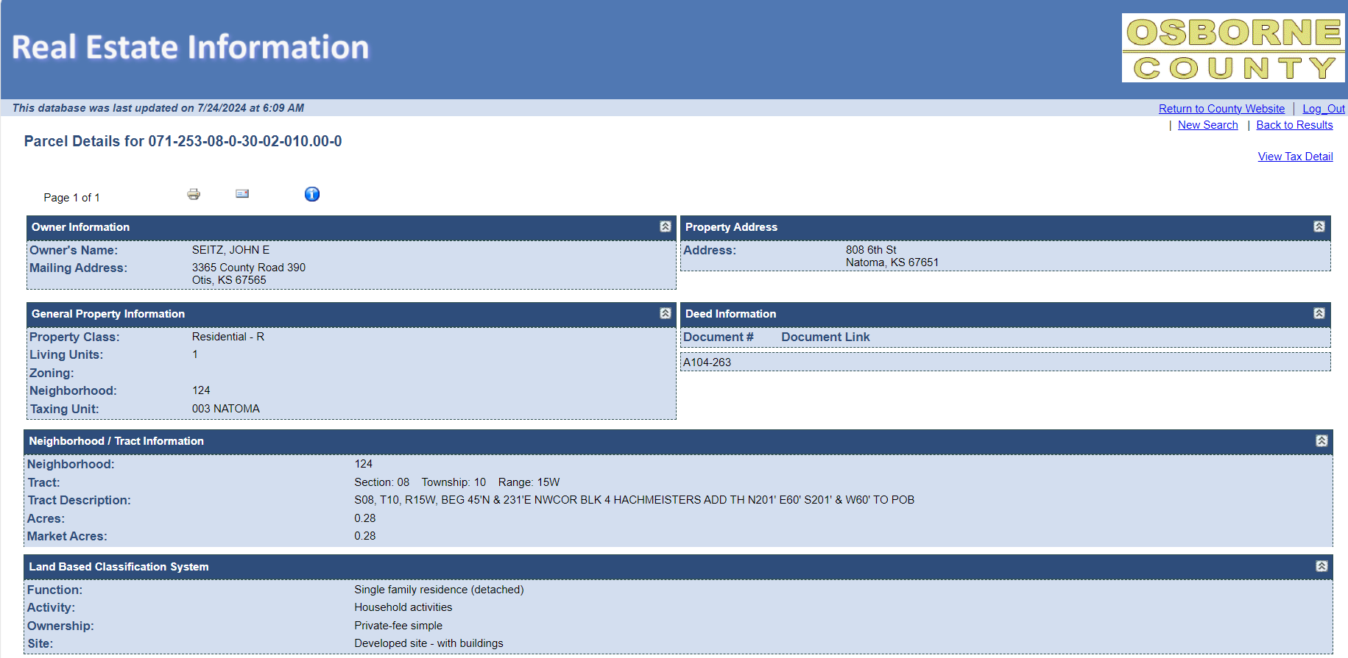

TaxHeader-TaxMailingAddress/TaxMailingAddress

Tax Header- Situs/SitusAddress

Taxheader-TRA/TRACode

Taxheader-TRA/TRAName

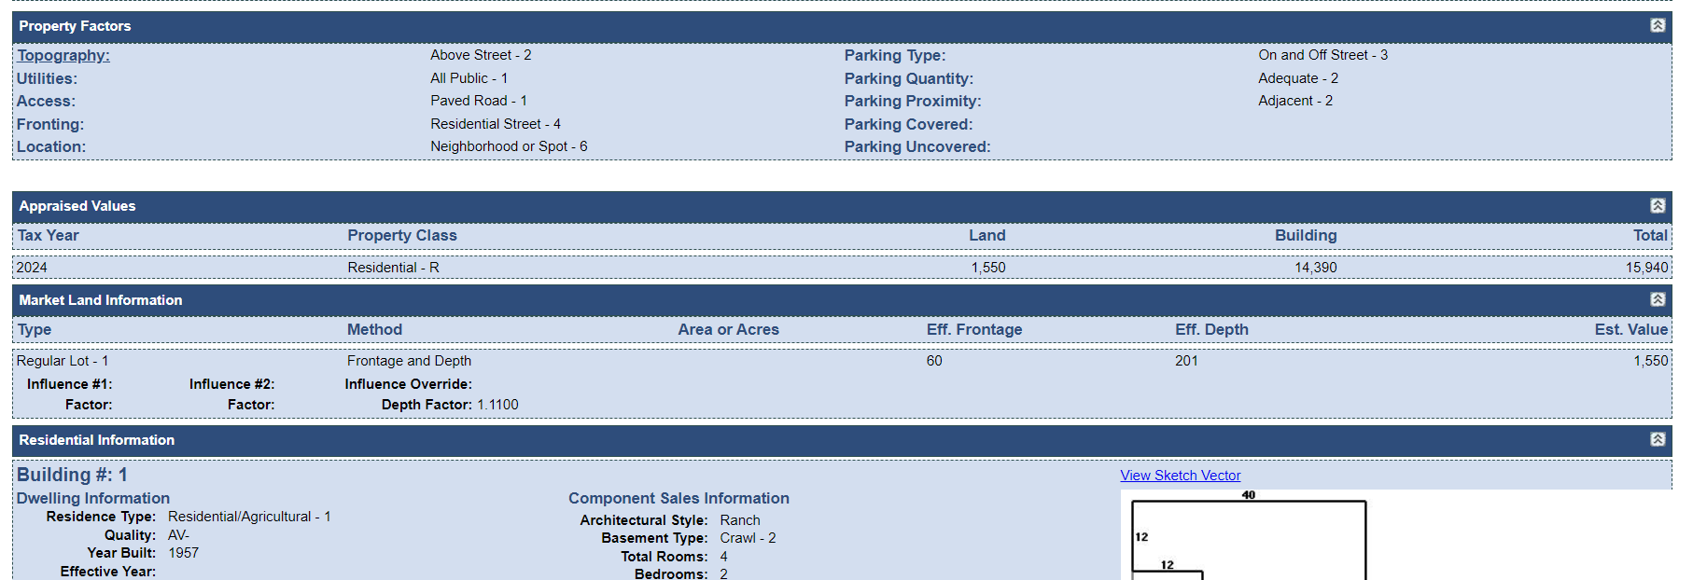

TaxDetail-TotalValue/TotalValue

TaxDetail-LandVal/LandVal

TaxDetail-ImpVal /ImpVal

TaxDetail-ValueYear/ValueYear

1. After Scraping **Real Estate Details, Click on “View Tax details”:**

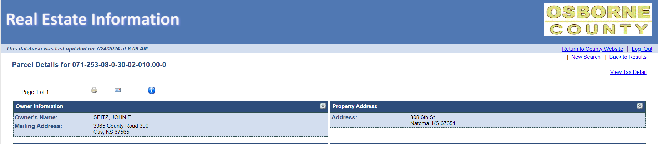

1. Click on **“Current Taxes”:**

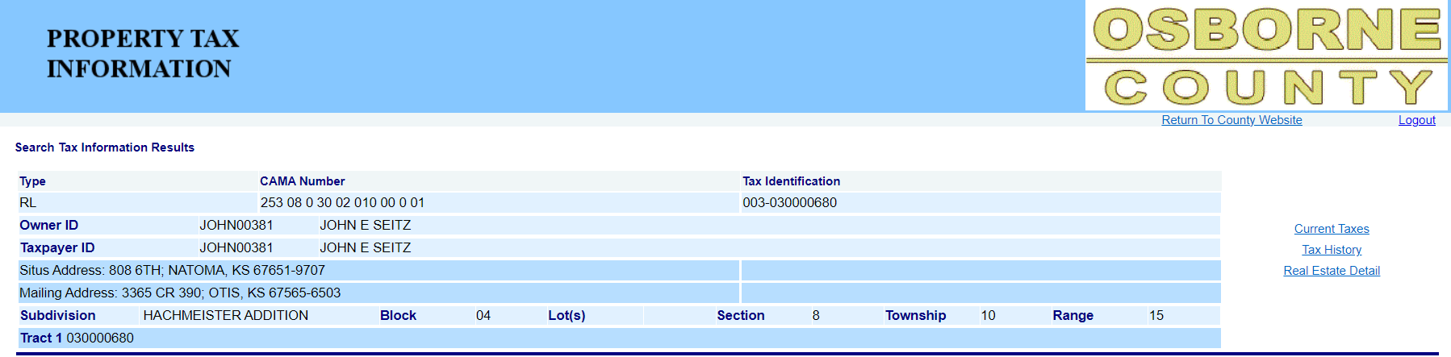

1. Screenshot and scrape the following results.

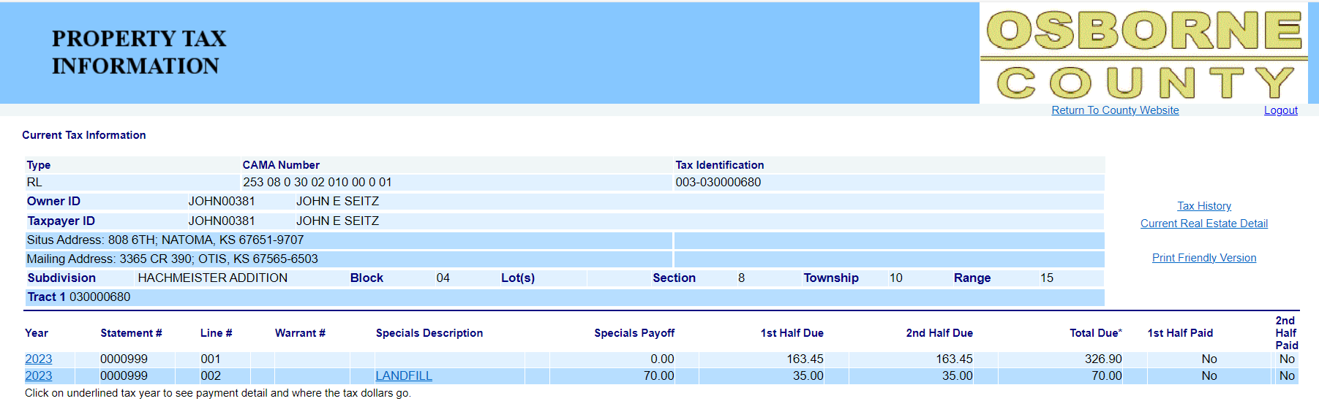

TaxDetail-SequenceNum/TaxType = “**Annual**”

ADD All 2nd half Due Amounts of current tax year then scrape as TaxDetail-TaxInstallment2/Installment2

ADD All 1st half Due Amounts of current tax year then scrape as TaxDetail-TaxInstallment1/Installment1

If wording appears as “yes” then scrape Tax Detail-Status/Status1 = Paid. If wording appears as “No” then follow status rules

If wording appears as “yes” then scrape Tax Detail-Status/Status2 = Paid. If wording appears as “No” then follow status rules

TaxHeader-Taxyear/TaxYear and

TaxDetail-TaxYear / TaxYear &

TaxDetail-ValueYear/ValueYear

1. Click on **“Year”:**



1. Screenshot and scrape the following.

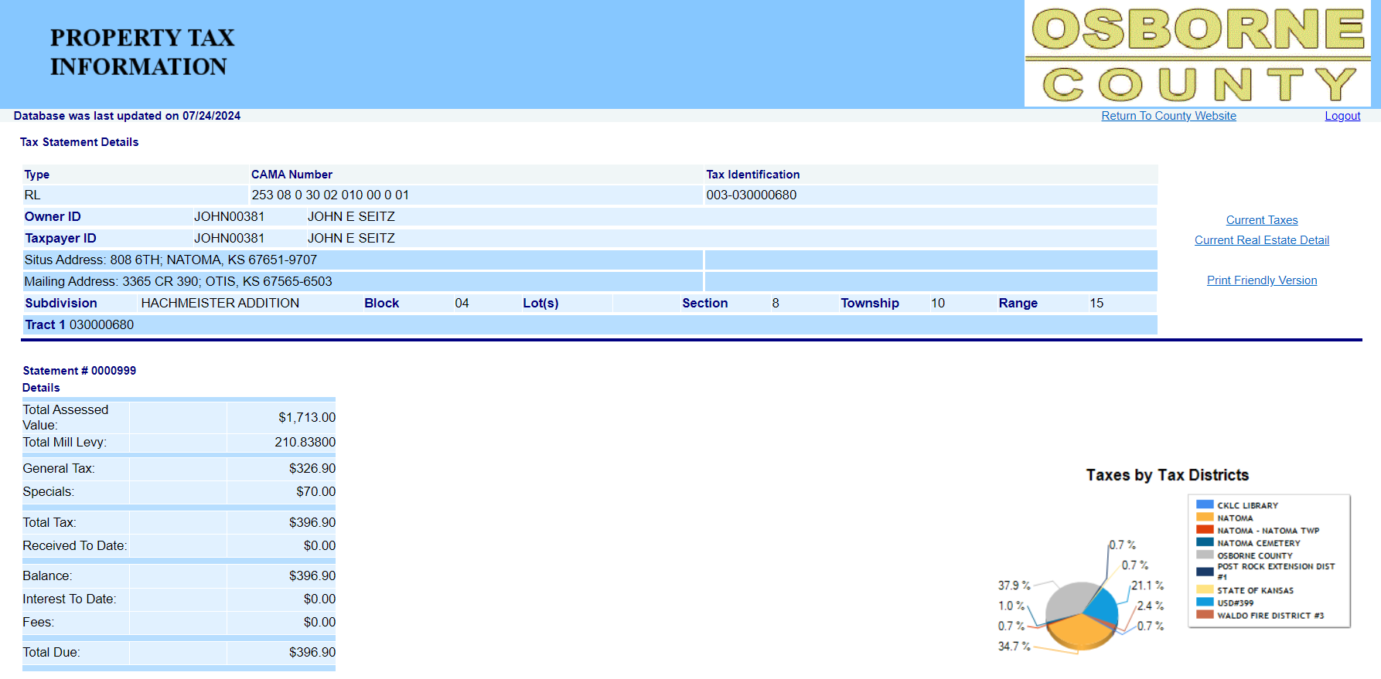

If the Tax amount under receipt information is $0.00 and Total Due >$0.00 then Add Fees + Interest and scrape as TaxDetail-Interest1/Interest1

If the Tax amount under receipt information > $0.00 and Total Due is $0.00 then Add Fees + Interest and scrape as TaxDetail-Interest1/Interest1

if the Tax amount under receipt information > $0.00 and Total Due >$0.00 then Add Fees + Interest and scrape as TaxDetail-Interest2/Interest2

TaxDetail-Due1/AmountDue1 & TaxDetail-Due2/AmountDue2= $0.00 if Total due = $0.00

if Tax amount = $0.00 or none for current tax year under receipt information and total due >$0.00 then divide total due into two installments and scrape each amount as TaxDetail-Due1/AmountDue1 & TaxDetail-Due2/AmountDue2 respectively

if Tax amount > $0.00 for current tax year under receipt information and total due >$0.00 scrape total due as TaxDetail-Due2/AmountDue2 & TaxDetail-Due1/AmountDue1 = $0.00

TaxDetail-Due1/AmountDue1= 1st Installment-Tax amount under receipt information & TaxDetail-Due2/AmountDue2 = Total Due – (1st Installment-Tax amount under receipt information), when Tax amount under receipt information is less than 50% of Total Tax and Total Due is >$0.00

Combine General Tax + Specials than scrape as TaxDetail-TotalTax1/ TotalTax1

TaxDetail-TotalValue/TotalValue

TaxDetail-NetVal /NetVal

TaxDetail-PartialPayAmt1/PartialPayAmt1 &

TaxDetail-Partia2PayAmt2/PartialPayAmt2 = $0.00 if Tax = 0.00 or None

If Tax > $0.00 and Total due= $0.00 under details tab then divide Tax amount by two and scrape the amounts as PartialPayAmt1 and PartialPayAmt2 respectively

If Tax >$0.00 and Total due> $0.00 under details tab then scrape Tax amount as PartialPayAmt1 and PartialPayAmt2 =$0.00

When Total due under Details section is $0.00 then scrape this date to both fields

TaxDetail-PaymentDate1/DatePaid1 &

TaxDetail-PaymentDate2/DatePaid2

When Total due under Details section is $0.00 and tax amount > 0.00 then scrape this date as TaxDetail-PaymentDate1/DatePaid1

**Status Rules**

**A. Status Rules – Due/Delinquent**

1. If AmountDue1 is > $0.00 and if “Current Date” is equal or prior to 12/20 of tax year, then status1 = Due.
2. If AmountDue2 is > $0.00 and if “Current Date” is equal or prior to 05/10 of tax year +1, then status2 = Due.
3. If AmountDue1 is > $0.00 and if “Current Date” is after 12/20 of tax year, then status1 = Delinquent.
4. If AmountDue2 is > $0.00 and if “Current Date” is after 05/10 of tax year+1, then status2 = Delinquent.

**B. Status Rules – Paid**

1. If AmountDue1 is = $0.00 then status1 = Paid.
2. If AmountDue2 is = $0.00 then status2 = Paid.

**Sample for Prior Year Taxes - Paid:**

1. Click on **“Tax History”:**

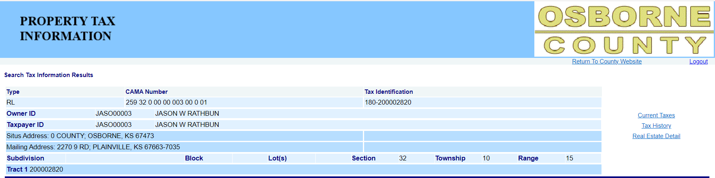

1. After scraping the current year details, below scrape rules are appliable for all prior year taxes which the **Total Due** column **is $0.00** and status is **“YES”**. then scrape those years are prior year paid. Click on “**Prior Year**”:

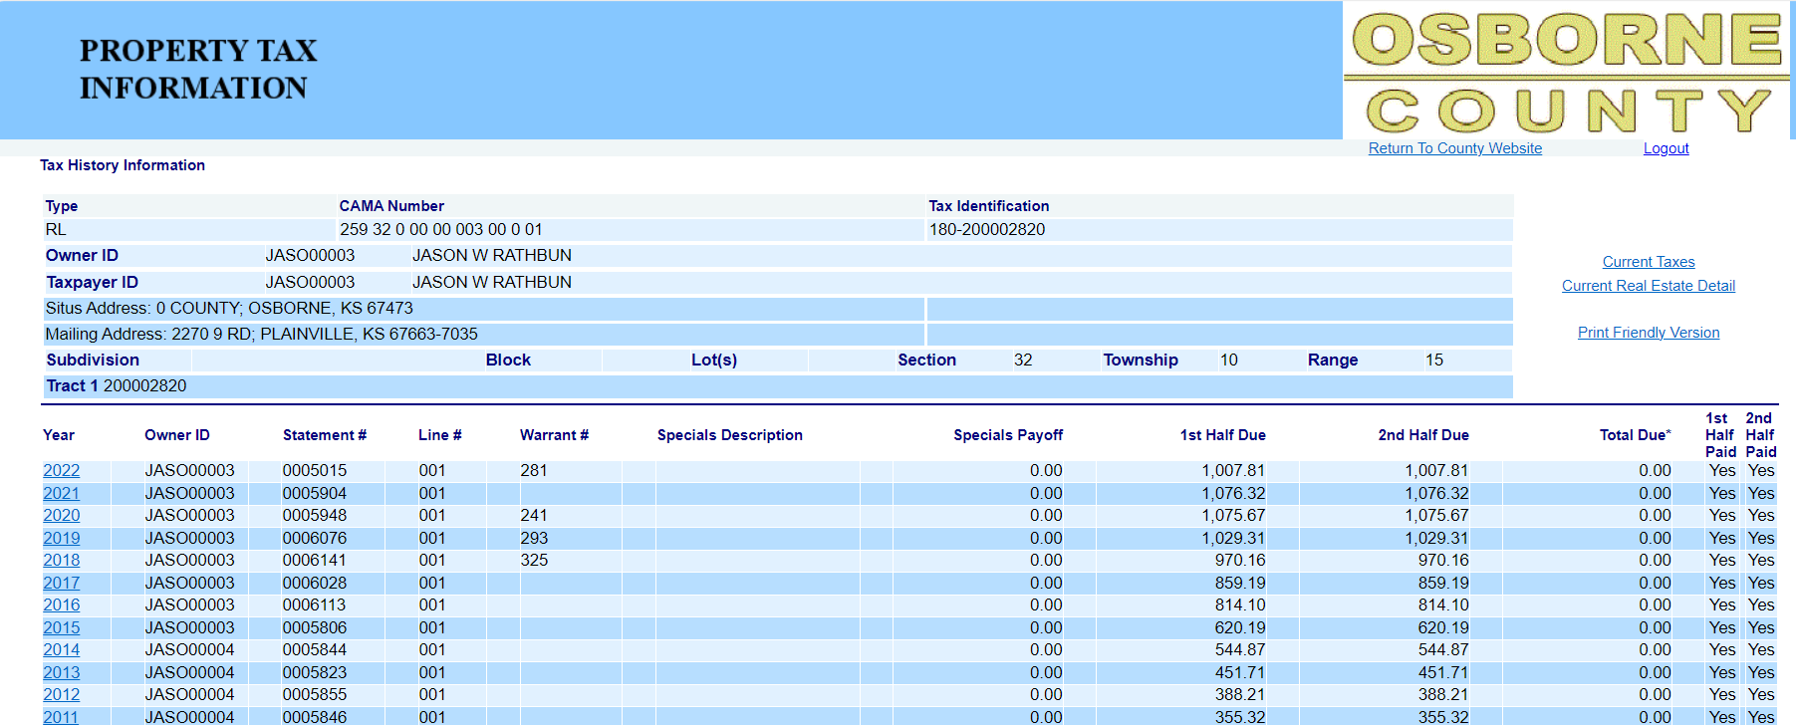

1. Screenshot and scrape the following result:

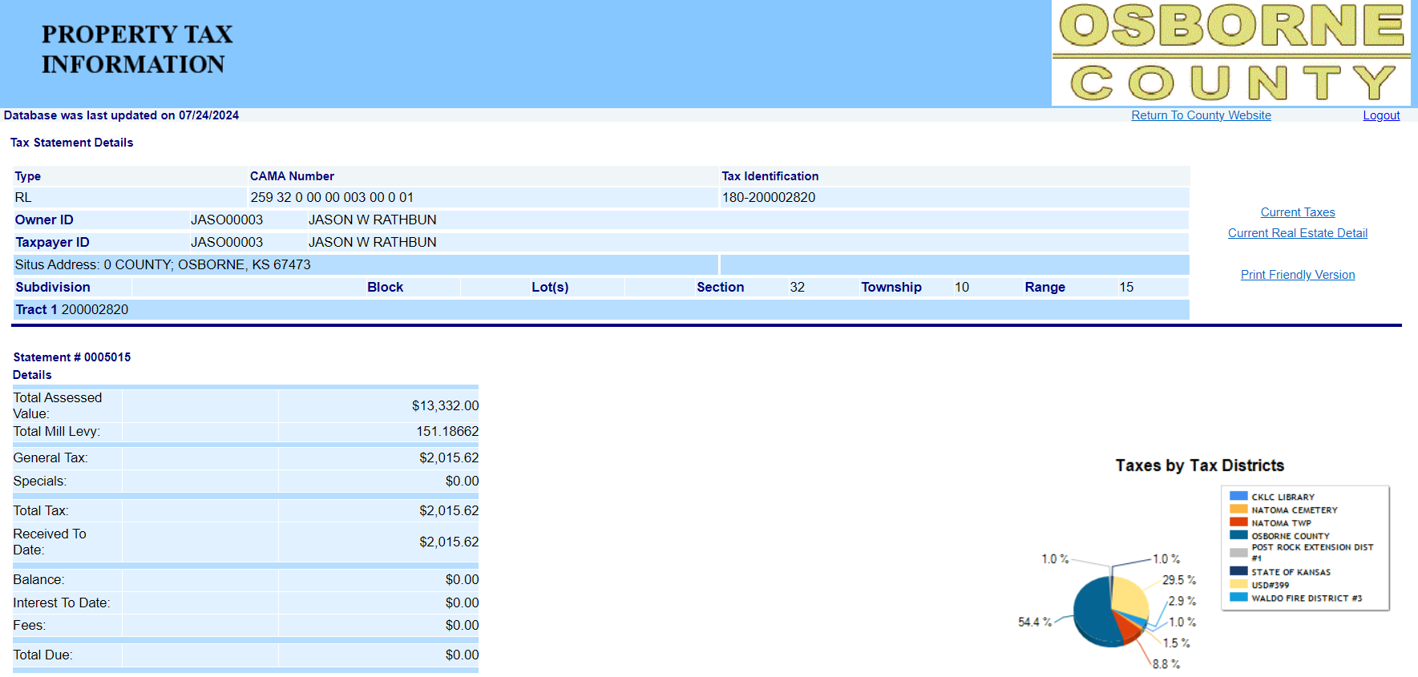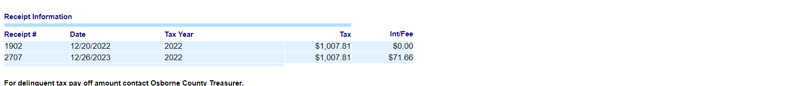

Add both Tax amounts of same tax year(for ex: in the screenshot tax year is 2022) then scrape TaxDetail-PartialPayAmt1/PartialPayAmt1

TaxDetail-Status1/Status1 = “**Paid”**

Combine General Tax + Specials than scrape as TaxDetail-TaxInstallment1/Installment1 &

TaxDetail-TotalTax1/ TotalTax1

TaxDetail-Due1/AmountDue1

If total due is =$0.00 then Add Fees + Interest and scrape as TaxDetail-Interest1/Interest1

TaxHeader-Taxyear/TaxYear and

TaxDetail-TaxYear / TaxYear &

TaxDetail-ValueYear/ValueYear

TaxDetail-SequenceNum/TaxType = **“Prior Year Annual”**

Scrape latest date as TaxDetail-PaymentDate1/DatePaid1

1. **Repeat the steps 22 and 23, if more than one prior year with Total due column is $0.00 and status is YES.**

**Prior Year Delinquent Taxes**

1. Select Tax Type **“Real Estate (RL)** and Enter **“CAMA Number”** and click on **“FIND NOW”**

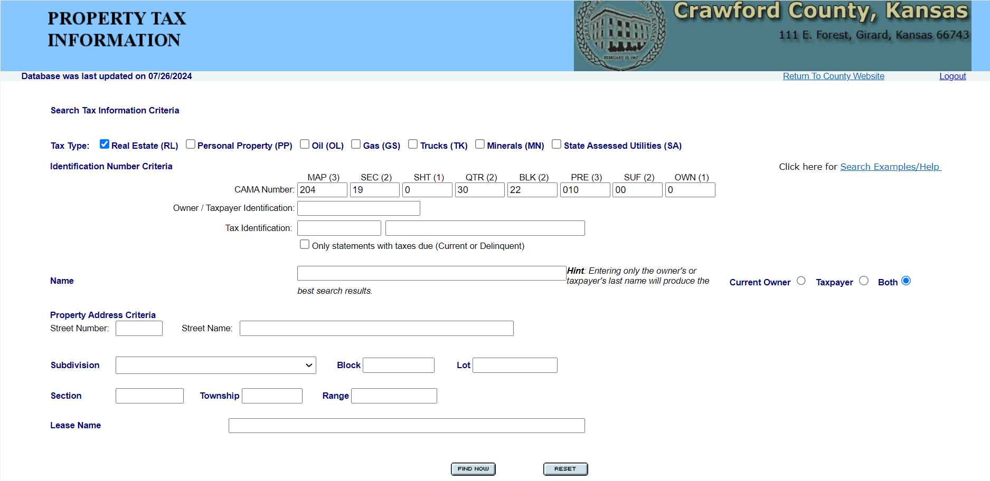

1. Click on **“Tax History”**

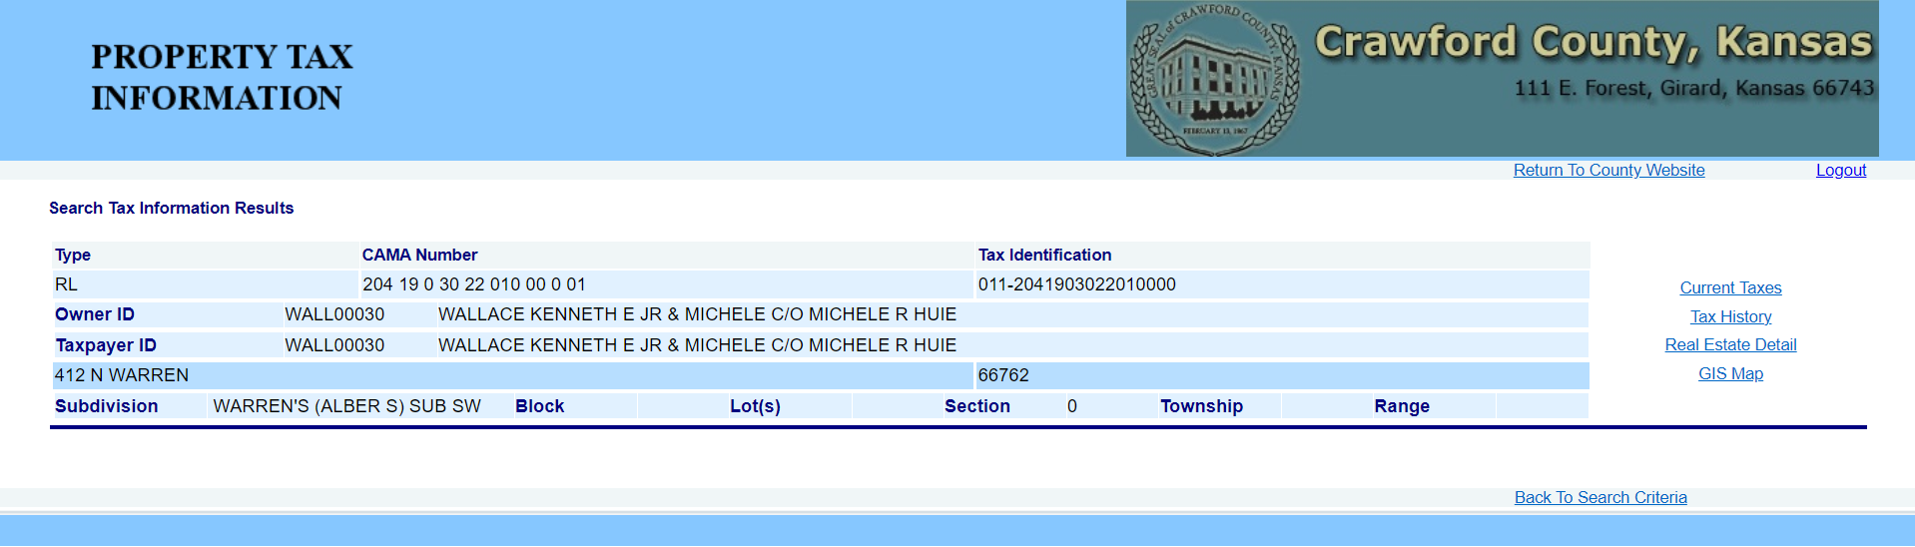

1. Find prior years (other than Current tax year) for which the **Total Due** column is > $0.00 and then scrape as delinquent tax years.

In the below example,2019 to 2022 are delinquent prior years. Screenshot the page and scrape the following:

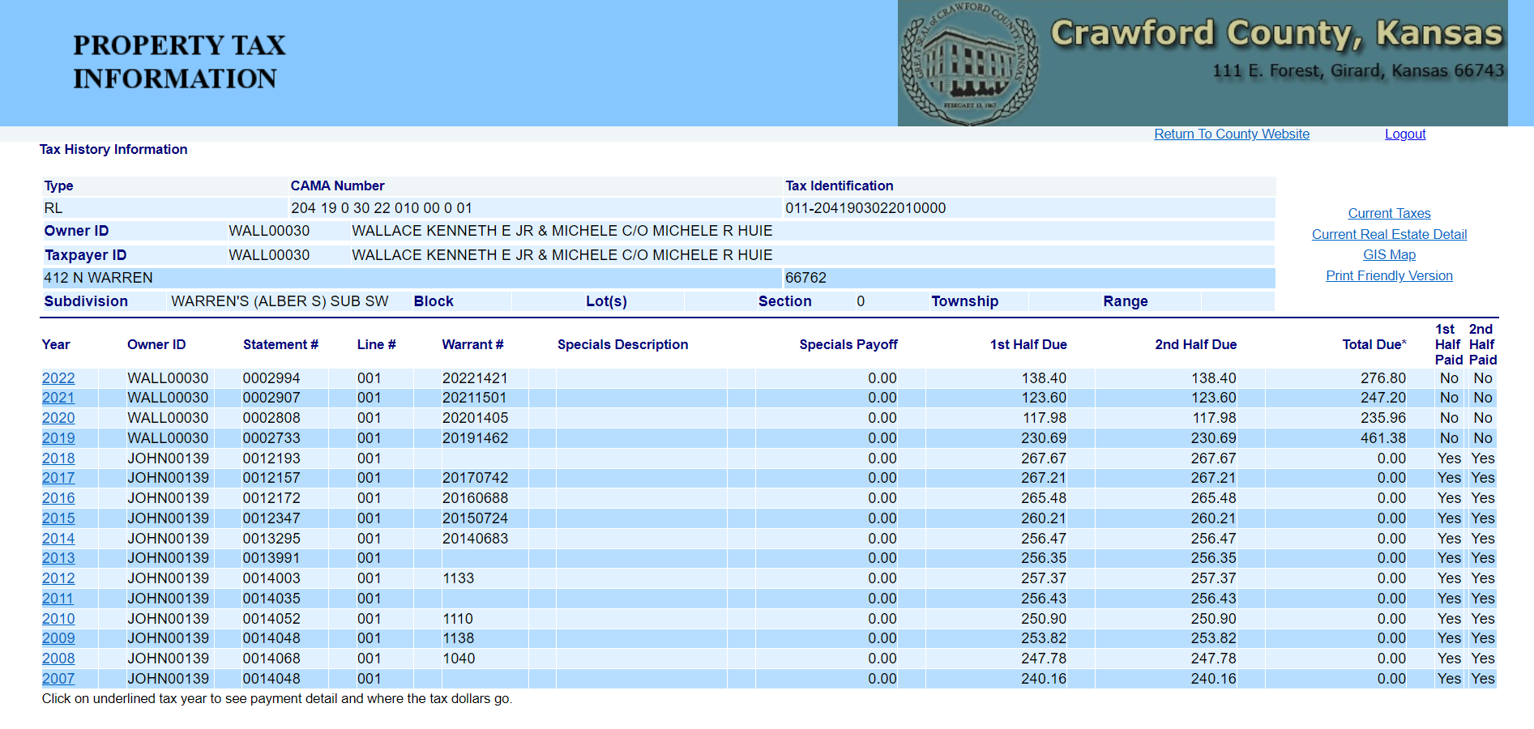

Add All prior years Total Dues (Don’t include Current year total due amount) than scrape as TaxRedemption-RedemptionAmt-seq1/ RedemptionAmount1

Scrape only once in max delinquent tax

TaxRedemption-RedemptionDate-seq 1/ RedemptionDate1  
(Take current month and include last day of the month & current year when this page is pulled and scrape as in following format “May 31st2024” (MM-DD-YYYY)

Scrape only once in delinquent tax type

TaxDetail-Status1/Status1 = **Delinquent**

TaxDetail-SequenceNum/TaxType = “**Delinquent**”

TaxHeader-Taxyear/TaxYear and TaxDetail-TaxYear / TaxYear

1. Click on **“prior year”**



1. Screenshot and scrape the following:

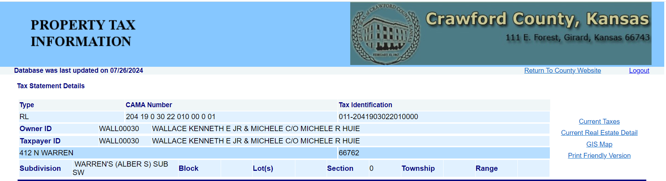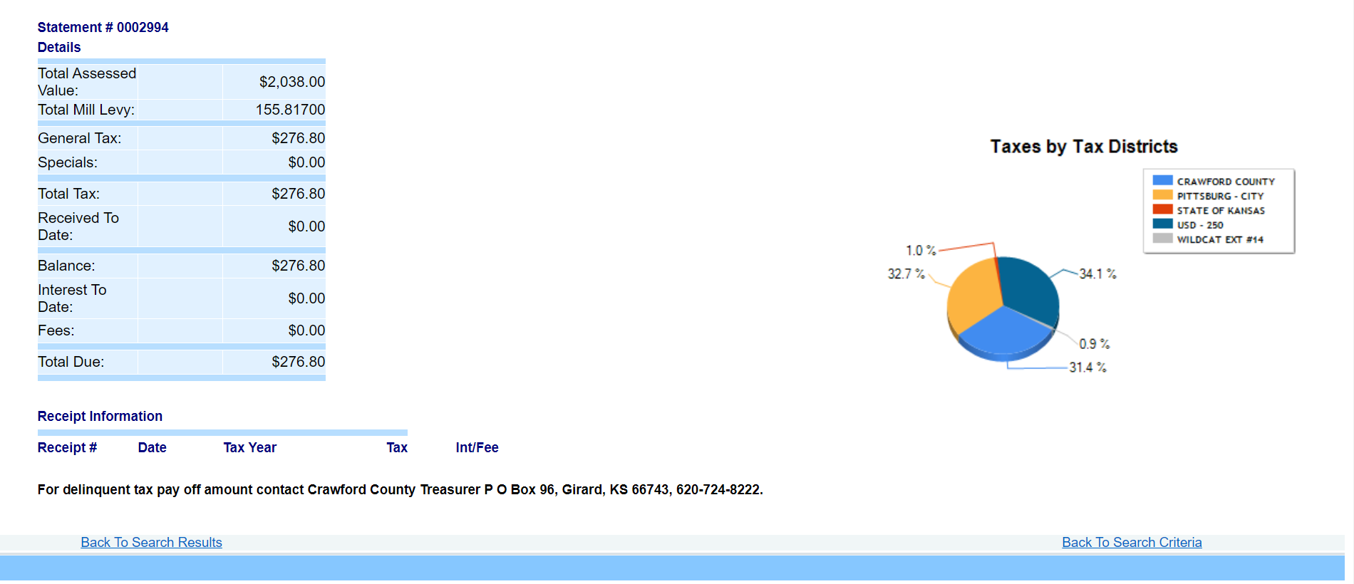

TaxDetail-PartialPayAmt1/PartialPayAmt1

Add General Tax + Specials than scrape as TaxDetail-TaxInstallment1/Installment1 &

TaxDetail-TotalTax1/ TotalTax1

TaxDetail-Due1/AmountDue1

Add Fees + Interest then scrape as TaxDetail-Interest1/Interest1

1. **Repeat the steps 25 to 29 if more than one prior year with Total due column is > $0.00**

**Delinquent sample when prior years have multiple Line# for same year:**

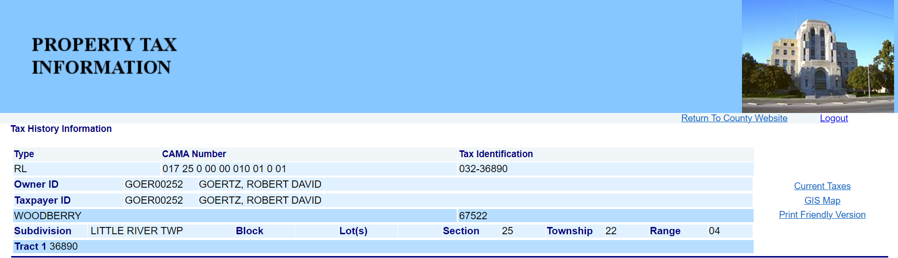

TaxDetail-Status1/Status1 = **Delinquent**

TaxDetail-SequenceNum/TaxType = “**Delinquent**”

TaxHeader-Taxyear/TaxYear and TaxDetail-TaxYear / TaxYear & TaxDetail-ValueYear/ValueYear

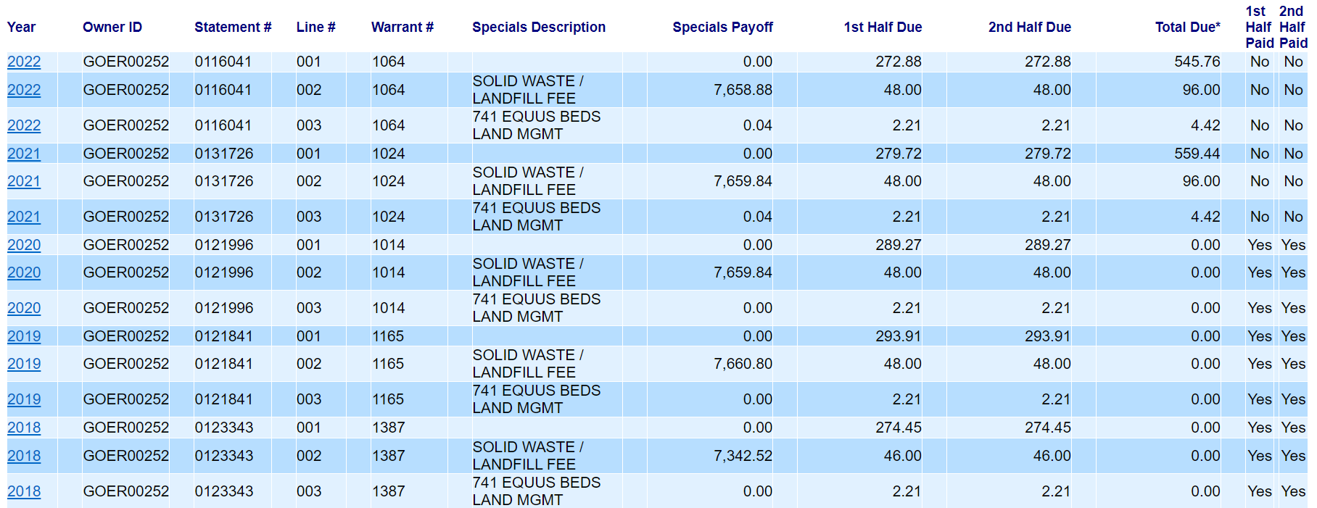

Combine all same year Line #1, #2, #3 than scrape as TaxDetail-Due1/AmountDue1

1. Click on **“prior year”:**



1. Screenshot and scrape the following:

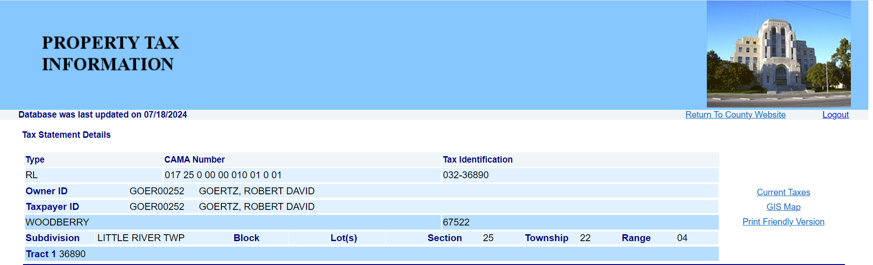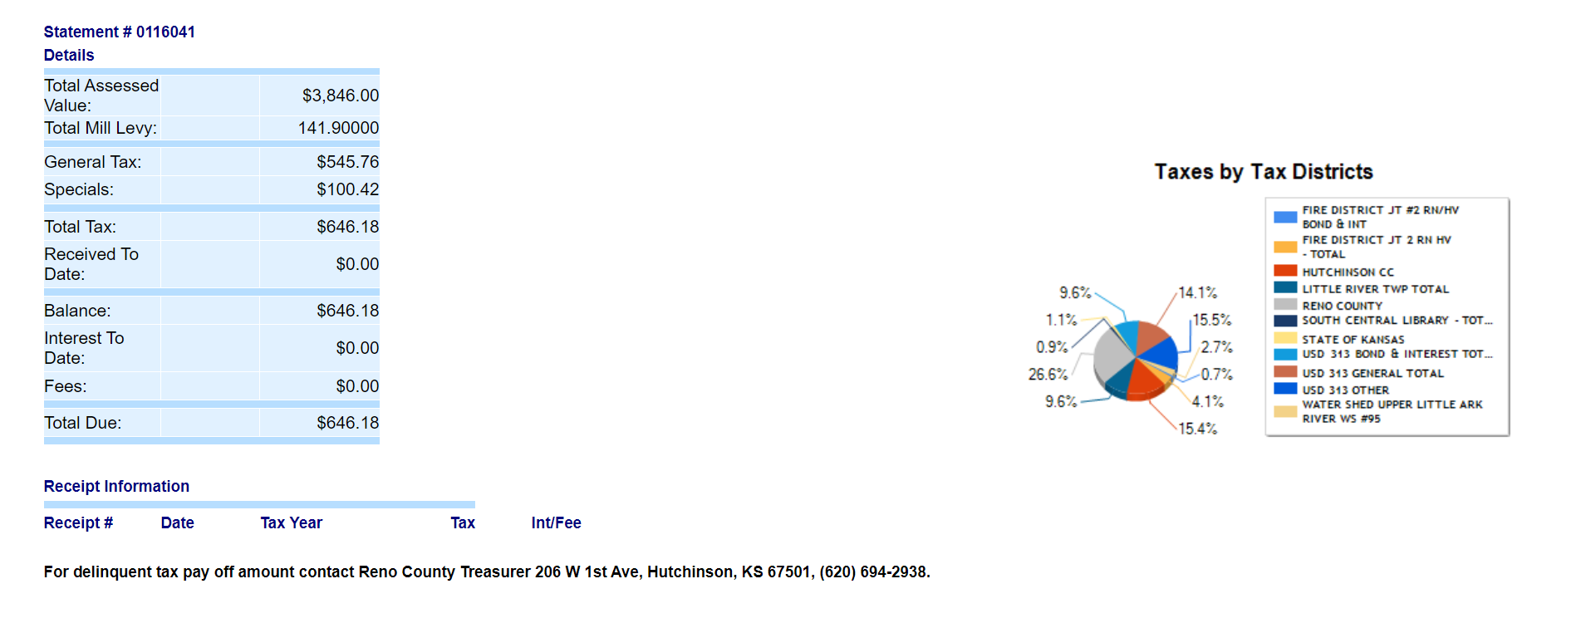

Combine General Tax + Specials than scrape as TaxDetail-TaxInstallment1/Installment1 &

TaxDetail-TotalTax1/ TotalTax1

TaxDetail-PartialPayAmt1/PartialPayAmt1

Add Fees + Interest then scrape as TaxDetail-Interest1/Interest1

**END**

**Reviewer: Neeraja Medikonda**

**Date: 11/01/2024**

**Author: B. Dhanalakshmi**

**Date: 03/27/2024**

**Date: 07/25/2024**

**Reviewer: E Rajeshwari**

**Date: 08/01/2024**